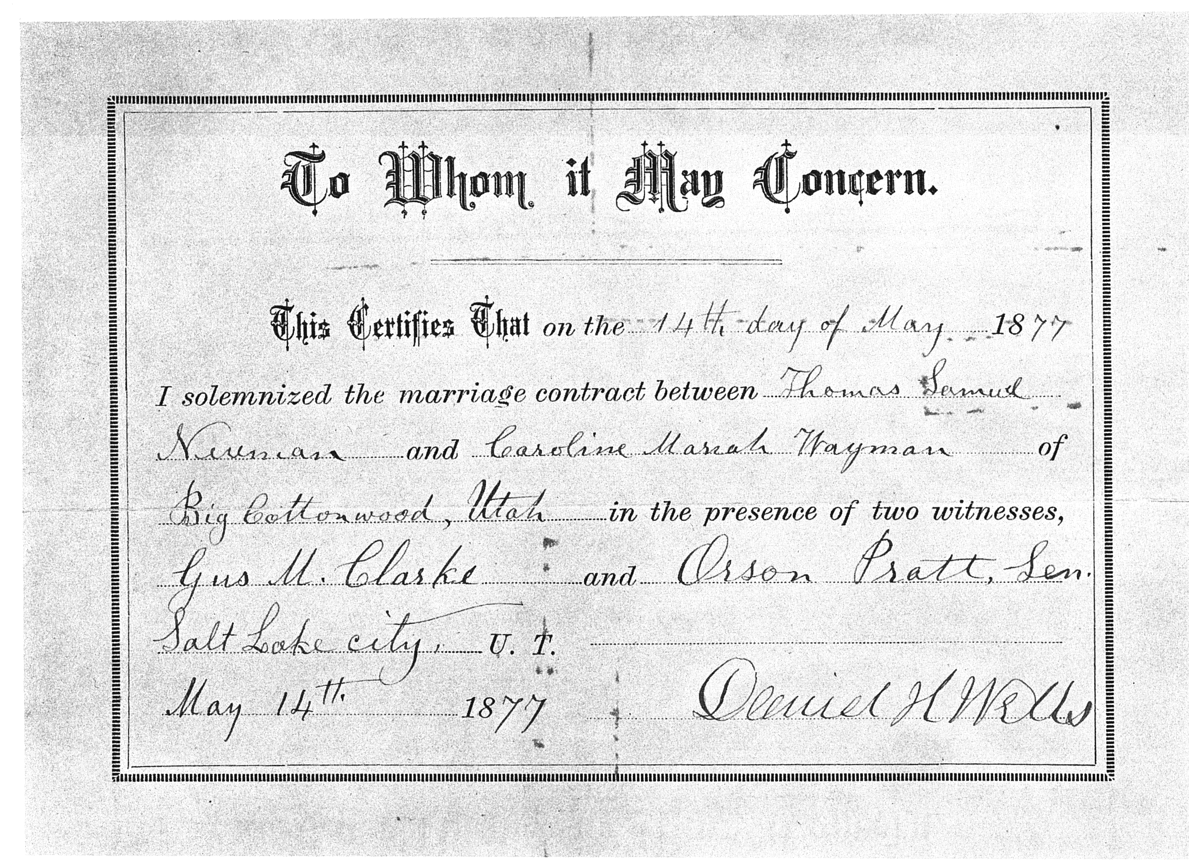
Marriage Certification for Thomas Samuel Newman and Caroline Mariah Wayman

